Workout App Debugging and Testing

When analyzing the code, I noticed a couple things.

First off, the select() function should be guarded, with something like this:
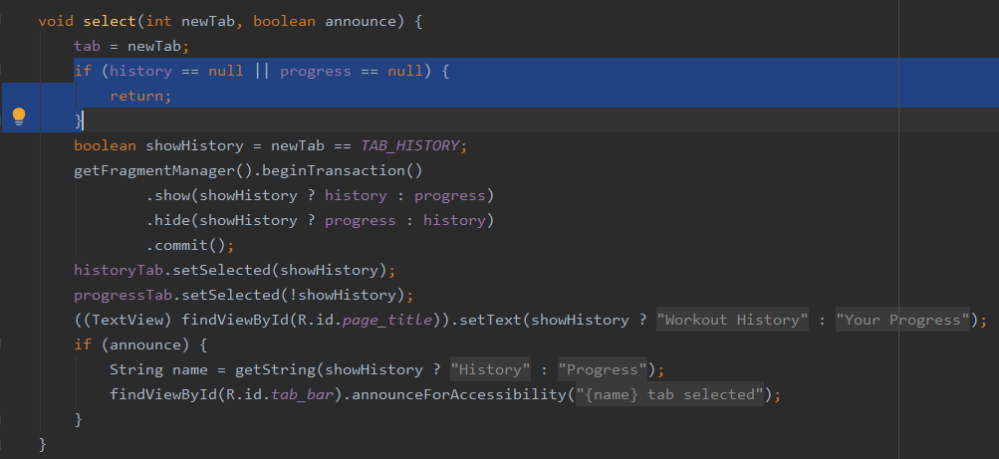
The reason for this is that after a rotation, the FragmentManager could potentially restore fragments later than onCreate() finishes, which would cause findFragmentByTag to throw null, which could cause the app to crash if show() or hide() is called on a null fragment. This guard will prevent the lifecycle from disrupting the flow of the select function and avoid the potential crash.

Next, the onDestroy() function.
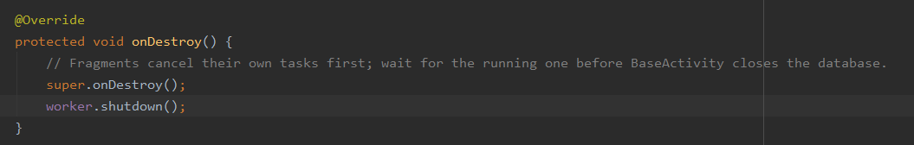
I swapped the order of the two lines of code in the function because otherwise, a race condition occurs where tasks may attempt to access the database even after it is closed when the phone rotates during the app’s closure, or on slower devices where the app may not close immediately after an action that would terminate the current lifecycle occurs. This would result in, at best, a crash, and at worst, some data loss/corruption in the database, which is very much not good. By swapping the order, fragment tasks will not be able to access the database after a shutdown, which will prevent such corruption from occurring.

